Name:- Document-4
Solution:-

Updated Code for EmployeeController.cs

using Microsoft.AspNetCore.Authorization;
using Microsoft.AspNetCore.Mvc;
using WorkingSwaggerDemo.Filters;
using WorkingSwaggerDemo.Models;

namespace WorkingSwaggerDemo.Controllers
{
[ApiController]
[Route("api/Emp")]
[ServiceFilter(typeof(CustomAuthFilter))]
[ServiceFilter(typeof(CustomExceptionFilter))]
public class EmployeeController : ControllerBase
{
private List<Employee> _employees;

public EmployeeController()
{
_employees = GetStandardEmployeeList();
}

private List<Employee> GetStandardEmployeeList()
{
return new List<Employee>
{
new Employee
{
Id = 1,
Name = "GAUTAM KUMAR",
Salary = 50000,
Permanent = true,
DateOfBirth = new DateTime(2003, 11, 5),
Department = new Department { Id = 101, Name = "IT" },
Skills = new List<Skill>
{
new Skill { Id = 1, Name = "C#" },
new Skill { Id = 2, Name = "ASP.NET Core" }
}
}
};
}
[HttpPut("{id}")]
[ProducesResponseType(StatusCodes.Status200OK)]
[ProducesResponseType(StatusCodes.Status400BadRequest)]
public ActionResult<Employee> Put(int id, [FromBody] Employee updatedEmp)
{
if (id <= 0)
return BadRequest("Invalid employee id");

var existingEmp = _employees.FirstOrDefault(e => e.Id == id);

if (existingEmp == null)
return BadRequest("Invalid employee id");

existingEmp.Name = updatedEmp.Name;
existingEmp.Salary = updatedEmp.Salary;
existingEmp.Permanent = updatedEmp.Permanent;
existingEmp.DateOfBirth = updatedEmp.DateOfBirth;
existingEmp.Department = updatedEmp.Department;
existingEmp.Skills = updatedEmp.Skills;

return Ok(existingEmp);
}

[HttpGet]
[AllowAnonymous]
[ProducesResponseType(StatusCodes.Status200OK)]
[ProducesResponseType(StatusCodes.Status500InternalServerError)]
public ActionResult<List<Employee>> Get()
{

throw new Exception("This is a test exception from GET.");

// return Ok(_employees); // Use this after testing exception filter
}
[HttpPost]
[ProducesResponseType(StatusCodes.Status200OK)]
[ProducesResponseType(StatusCodes.Status400BadRequest)]
public IActionResult Post([FromBody] Employee emp)
{
if (emp == null || string.IsNullOrEmpty(emp.Name))
{
return BadRequest("Invalid Employee data");
}

return Ok($"Employee added: {emp.Name}");
}
}
}

TESTING WITH SWAGGER

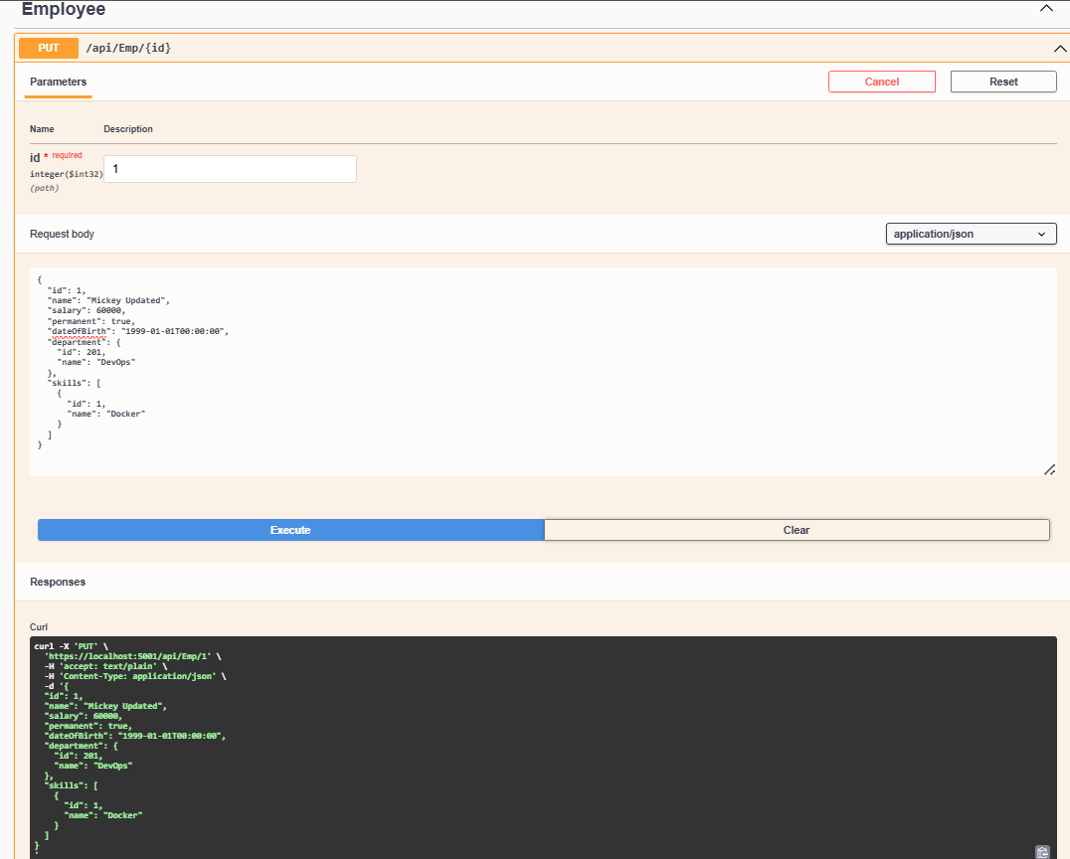

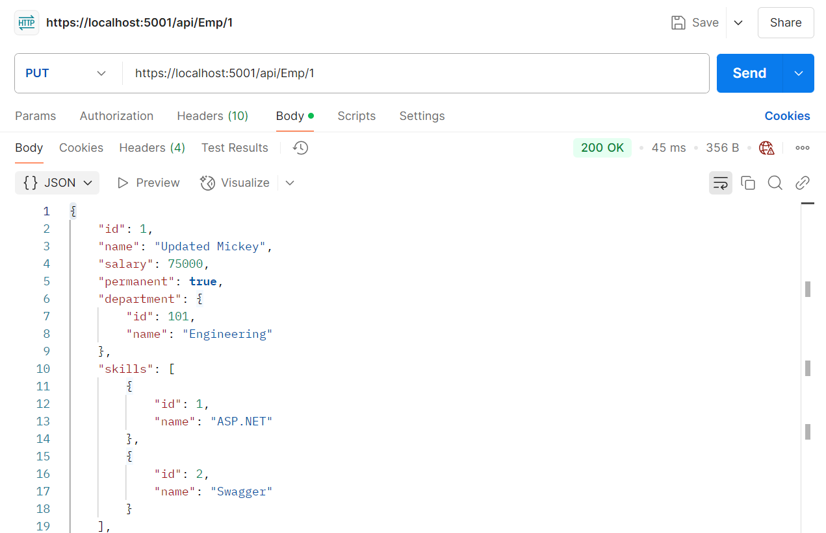
Check if the id value is lesser than or equal to 0. If true, throw BadRequest action result with the message ‘Invalid employee id’

